**Delaware School Climate Surveys Interpretation Worksheet**

**School Climate, Bullying, Engagement**

**HOME Version**

General Review Guidance:

* When reviewing data, note the number of respondents and reflect on percentage of eligible participants (p. 2 of Interpretation Guidelines). There may be fewer responses than expected due to data cleaning process.
* Note: If you notice grades listed outside of the population served, this is due to selection of an inaccurate grade when taking the survey. While the respondent’s grade info is null, their question responses are included in total scores.
* Overall, missing scores indicate there were fewer than 5 surveys available to score this item; therefore, the scores are not reported.

|  |  |  |  |  |
| --- | --- | --- | --- | --- |
| **Report Interpretation Key** | | | | |
| Scales |  | Score Types |  | Color Codes |
| School Climate |  | Average Item |  | **Bold** – Total Scores |
| Bullying |  | Percentage Response |  | Green – Favorable |
| Engagement |  |  |  | Red – Unfavorable |

|  |  |  |
| --- | --- | --- |
|  | **Favorable (GREEN)** | **Unfavorable (RED)** |
| **Scale** | **Average Item Score** | **Average Item Score** |
| School Climate & Engagement Scales | 3.2 and above | 2.5 and below |
| Bullying Scale | N/A | 3.0 and above |

|  |
| --- |
| **Average Item Score Calculation** |
| Determine: Do your respondents’ scores reflect positive or negative perceptions of school climate regardless of how your school compares to other schools?  *Average scores are calculated by finding the average of all responses for each item.*  **Example:**  Responses to Item 5 = 2, 3, 3, 3, 4, 2  2 + 3 + 3 + 3 + 4 + 2 = 17  17 / 6 = 2.83  Average Item Score = 2.83 |

**Determine:** **How does one know if differences in scores are significant?**

See pg. 2 of Interpretation Guidelines within the report.

**HOME DATA REPORT**

**School Climate Scale**

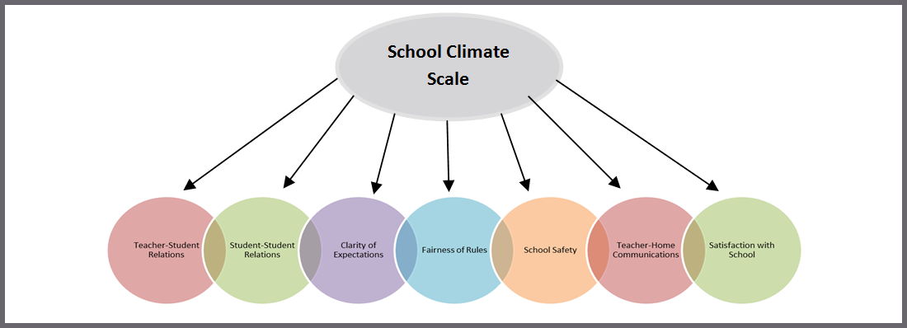

**Response Scale:** 1=Disagree A Lot 2=Disagree 3=Agree 4=Agree A Lot

**Average Item Score Comparison – School Climate Scale TABLE** (pg. 1)

|  |  |  |
| --- | --- | --- |
| **Table** | **Use to…** | **Ask yourself…** |
| Table I a. School Climate  Average Item Scores for All Grades Combined | Note the sizable strengths and considerable concerns for your school. A score of *3 or above* means that the respondents on average agree or agree a lot. | What areas are strengths for our school? What areas do we need to address? Are there differences within or between ethnicity groups? Do families view peer relationships positively? Do families feel rules are clear and fair? |

|  |  |  |
| --- | --- | --- |
| **School Climate Score Totals** | | |
| **Our Strengths** | | **Concerns to Address** |
|  | |  |
| **Additional Notes** | | |
|  | | |
| **School Climate Scale by *Ethnicity*** | | |
| **Our Strengths** | **Concerns to Address** | |
|  |  | |
| **Additional Notes** | | |
|  | | |

**Average Item Score Comparison – School Climate Scale BAR GRAPH** (pg. 2)

|  |  |  |
| --- | --- | --- |
| **Graph** | **Use to…** | **Ask yourself…** |
| Table I b. Average Item Score Comparison – School Climate Scale  *(Cross-Year Review)* | Note school’s average item scores per subscale for this school year and 2 previous years (if data are available). | By subscale and overall, have our average item scores per subscale increased, decreased, or maintained over the years? |

**\*Note: Current year data is represented in PURPLE**

|  |  |  |
| --- | --- | --- |
| **Our Increased Areas** | **Our Decreased Areas** | **Our Maintained Areas** |
|  |  |  |
| **Additional Notes** | | |

**School Climate Individual Item Responses** (pg. 3-4)

|  |  |  |
| --- | --- | --- |
| **Table** | **Use to…** | **Ask yourself…** |
| Table I c. School Climate  Individual Item Responses  *(Percentage Response Scores)* | Note individual items that caused scores to be low or high. By looking at this data, you can find out which items families feel strongly about and direct efforts accordingly. | Were there any individual items from a subscale that had a particularly high or low response percentage? How did this impact our overall score? What can we do to address these focus areas? |

|  |  |  |
| --- | --- | --- |
| **Subscales** | **Our Strengths** | **Concerns to Address** |
| Teacher-Student Relations |  |  |
| Student-Student Relations |  |  |
| Clarity of Expectations |  |  |
| Fairness of Rules |  |  |
| Teacher-Home Communications |  |  |
| School Safety |  |  |
| Satisfaction with School |  |  |
| **Additional Notes** |  |  |

**HOME DATA REPORT**

**Bullying Scale\***

*A high score on this subscale is negative because items are negatively worded

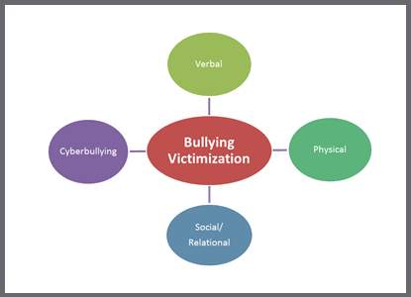

**Response Scale:** 1 = Never 2 = Less than once a month 3 = Once or twice a month

4 = Once a week 5 = Several times a week 6 = Every day

**Average Item Score Comparison – Bullying Scale TABLE** (pg. 4)

|  |  |  |
| --- | --- | --- |
| **Table** | **Use to…** | **Ask yourself…** |
| Table II a. Bullying  Average Item Scores for All Grades Combined | Note the sizable strengths and considerable concerns for your school. Explore families’ perceptions of the frequency of what types of bullying occur in the school. Keep in mind, lower scores are better. | What areas are strengths for our school? What areas do we need to address? Are there differences to explore within and between ethnicities? Are there differences in what types of bullying families perceive as a problem in your school? Do families see physical bullying as occurring more often than verbal? |

|  |  |
| --- | --- |
| **Bullying Average Item ScoreTotals** | |
| **Our Strengths** | **Concerns to Address** |
|  |  |
| **Additional Notes** | |
|  | |
| **Bullying by *Ethnicity*** | |
| **Our Strengths** | **Concerns to Address** |
|  |  |
| **Additional Notes** | |
|  | |

**Average Item Score Comparison – Bullying Scale BAR GRAPH** (pg. 5)

**\*Note: Current year data is represented in PURPLE**

|  |  |  |
| --- | --- | --- |
| **Graph** | **Use to…** | **Ask yourself…** |
| Table II b. Average Scores Comparison – Bullying Scale *(Cross-Year Review)* | Note school’s average item scores per subscale for this school year and 2 previous years (if data are available). | By subscale and overall, have our average item scores per subscale increased, decreased, or maintained over the years? |

|  |  |  |
| --- | --- | --- |
| **Our Increased Areas** | **Our Decreased Areas** | **Our Maintained Areas** |
|  |  |  |
| **Additional Notes** | | |

**Bullying Individual Item Responses** (pg. 6-7)

|  |  |  |
| --- | --- | --- |
| **Table** | **Use to…** | **Ask yourself…** |
| Table II c. Bullying  Individual Item Responses  *(Percentage Response Scores)* | Review families’ responses to the individual questions. Note individual items that caused subscale scores to be low or high. By looking at this data, you can identify items families note as occurring more or less frequently. | Were there any individual items from a subscale that had particularly high or low response percentage? How did this impact our overall score? What can we do to address these focus areas? |

|  |  |  |
| --- | --- | --- |
| **Subscales** | **Our Strengths** | **Concerns to Address** |
| Verbal Bullying |  |  |
| Physical Bullying |  |  |
| Social/Relational Bullying |  |  |
| Cyber Bullying |  |  |
| **Additional Notes** | | |

**HOME DATA REPORT**

**Engagement Scale**

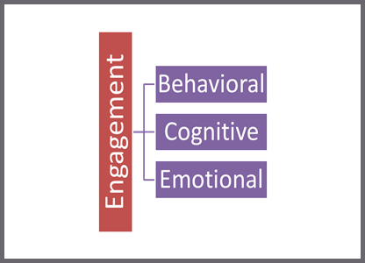

**Response Scale:** 1 = Disagree A Lot 2 = Disagree 3 = Agree 4 = Agree A Lot

**Average Item Score Comparison – Engagement Scale TABLE** (pg. 8)

|  |  |  |
| --- | --- | --- |
| **Table** | **Use to…** | **Ask yourself…** |
| Table III a. Engagement  Average Item Scores for All Grades Combined | Note the sizable strengths and considerable concerns for your school. A score of 3 or above means that the respondents on average agree or agree a lot. | What areas are strengths for our school? What areas do we need to address? Are there differences within or between race groups? Do our families report more cognitive, behavioral, or emotional engagement? |

|  |  |
| --- | --- |
| **Engagement Average Item Score Totals** | |
| **Our Strengths** | **Concerns to Address** |
|  |  |
| **Additional Notes** | |
|  | |

|  |  |
| --- | --- |
| **Engagement by *Ethnicity*** | |
| **Our Strengths** | **Concerns to Address** |
|  |  |
| **Additional Notes** | |
|  | |

**Average Item Score Comparison – Engagement Scale BAR GRAPH** (pg. 9)

**\*Note: Current year data is represented in PURPLE**

|  |  |  |
| --- | --- | --- |
| **Graph** | **Use to…** | **Ask yourself…** |
| Table III b. Average Score Comparison – Engagement Scale  *(Cross-Year Review)* | Note your school’s average item scores per subscale from this school year and the previous 2 years (if data are available). | By subscale and overall, have our average item scores per subscale increased, decreased, or maintained over the years? |

|  |  |  |
| --- | --- | --- |
| **Our Increased Areas** | **Our Decreased Areas** | **Our Maintained Areas** |
|  |  |  |
| **Additional Notes** | | |

**Engagement Individual Item Responses** (pg. 9)

|  |  |  |
| --- | --- | --- |
| **Table** | **Use to…** | **Ask yourself…** |
| Table III c. Engagement  Individual Item Responses  *(Percentage Response Scores)* | Note individual items that caused subscale scores to be low or high. By looking at this data, you can find out which items families feel strongly about and direct efforts accordingly. | Were there any individual items from a subscale that had particularly high or low response percentage? How did this impact our overall score? What can we do to address these focus areas? |

|  |  |  |
| --- | --- | --- |
| **Subscales** | **Our Strengths** | **Concerns to Address** |
| Behavioral Engagement |  |  |
| Cognitive Engagement |  |  |
| Emotional Engagement |  |  |
| **Additional Notes** | | |